
ECMO Herman Leunen
Geffenstraat 29
6844 HB ARNHEM
NEDERLAND
Tel.: 0031 06 41 56 05 54
Fax: 0031 481 35 03 07
Email: leunen@classicmotorsport.org
ENTRY FORM CEC-2

23-05-2015

Westerhausen Germany

Closing date 23-04-2015

By making your entry you confirm to agree with the ECMO rules

It is the responsibility of the individual rider himself to attend to a sufficient personal insurance.

STATEMENT:
“I have read and understand the actual regulations of ECMO on www.classicmotorsport.org” yes no

download, fill in by computer and send by mail before the closing date as attachment or
download, fill in by handwriting in BLOCK letters and send before the closing date by fax or post mail

Surname
1st name
Street and nr.
Zipcode
City
Country
Date of birth
Phone nr.
Fax nr.
E-mail address
Own AMB-MX transponder | Yes no | Number:
Personal insurance | Yes

class | brand of bike | year of construction
35 +
50 +
60 +
66 +
70 +

Your start-number depends on your result of the last year.

Penalty fee after the closing date € 10,00. So send your entry-form before the closing date
It is the rider’s own responsibility to inform himself about actual regulations.
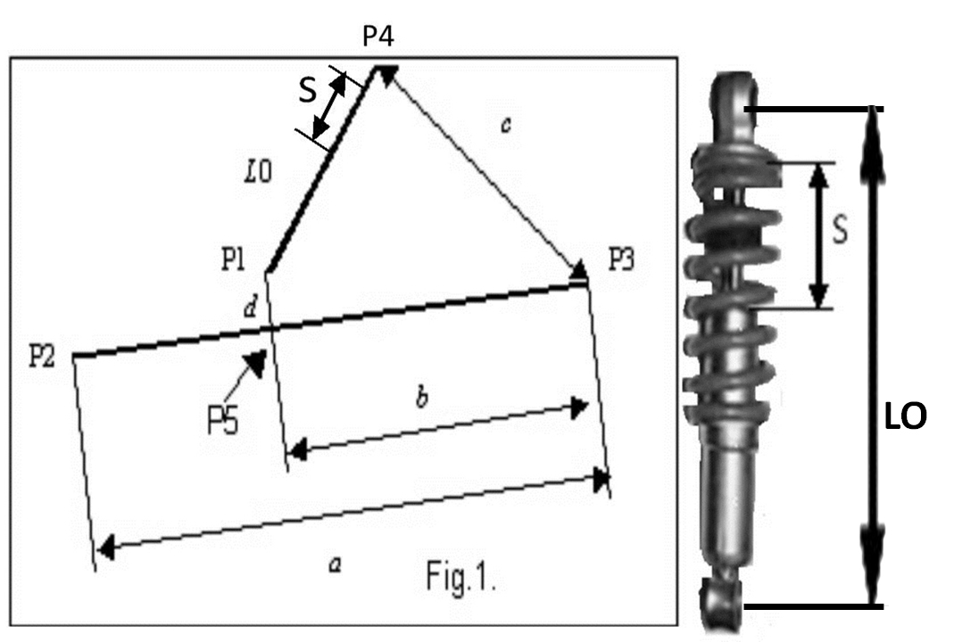
Data of the bike You are obliged to fill in and to
demonstrate these data at the technical inspection
a | mm
b | mm
c | mm
d | mm
Lo | mm
L | mm
Result rear suspension | mm
Result rear suspension max. 130 mm
See for Ruben Mild rear wheel suspension calculation www.classicmotorsport.org

